Product Design
Team Fourtran - SWEN261-Team D- Section 5

Architectural Model
This diagram represents the major subsystems of the product. Initially focus on the domain layer and its components before decomposing the user interface component. Note that a common interface allows both the GUI and a Command Line Interface to access the domain model in the same manner without regard to the type of presentation technique.

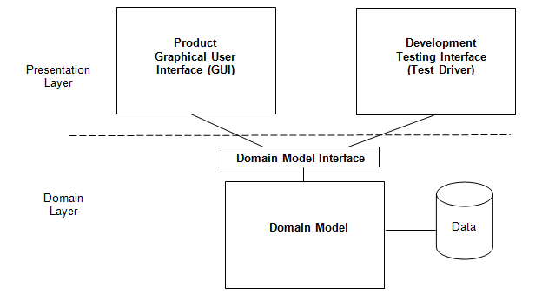

Components and Functions
System | Component state:  - ShareZone - A ShareZone that system will manage  Component behavior:  - register - Registers user for a ShareZone
Admin | Component state:  - name - Name of the admin  - email - Conctact email for the admin  Component behavior:  - editUser - Admin can edit user account information, like username, location, and password.  - editShareZone - Admin can edit ShareZone attributes like location  - editTools - Admin can edit the tools that are in the ShareZone
ShareZone | Component state:  - users - The user registed in the ShareZone  Component behavior:  - getUsers - returns a list of users in the ShareZone  - getStatistics - return the specified statistics  - getMasterToolList - return a list containing all Tools
User | Component state:  - Name - full name of user  - Email - email adress for user  - Statistics - how many tools borrowed, what tool is borrowed the most, how many transactions a day/moth, etc..  Component behavior:  - deregister - remove user and tools from database  - manageAccount - edits the attributes of the user
ToolList | Component state:  - borrowedTools - tools that are currently being borrowed for the user.  - ownedTools - tools that are currently owned by the user  Component behavior:  - getBorrowedTools - gets a list of the borrowed tools from the database  - getOwnedTools - gets a list of owned tools from the database  - registerTool - allow a user to register a tool in their ownedList  - deregisterTool - allow a user to deregister a tool in their borrowedList
Tool | Component state:  - name - name of tool  - description - description of tool  - picture - actual picture of tool  - status - what is the current tool status; for example, reserved, available, requested, unavailable  - owner - Owner of the tool -- not the borrowers  - currentOwner - who is currently in possession of the tool  - availability - if the tool is available or not at the current time.  - pickupArrangements - arrangements for pick up for a given reserverd day.  - quantityTotal - how many of the given tool the owner has.  - specialInstructions - any owner specific information for the tool -- optional  Component behavior:  - borrow - the process of borrowing the tool  - lend - the process of lending a tool  - edit - edit the tool’s attributes  - return - the tool is being return back to the original owner.
Calender | Component state:  - dateRange - the range of dates available for a User to view for a Tool  - blackoutDays - the present/future days a Tool is unavailable for all Users  - requestedDays - the present/future days a Tool is requested by a User  - reservedDays - the present/future days a Tool is reserved for a User  Component behavior:  - isRangeValid - return a boolean describing if a User selected range of dates is available for the tool selected
Statistics | Component state:  - lastTransaction - return the last transactions  Component behavior:  - getMostUsedTools - return the 10 most transacted Tools  - getMostActiveLender - return the User who has lent the most Tools  - getMostActiveBorrower - return the User who has borrowed the most Tools  - getLastTransactions - return the last 15 transactions
Shed Coordinator | Component state:  Component behavior:  - manageToolShed - allow coordinator to access Shed and modify status of Tools
Tool Shed | Component state:  - location - the location of Shed  - owner - the Owner of Shed  Component behavior:  - editToolList - allow User to modify a Tool’s attributes

Class Diagram(s)

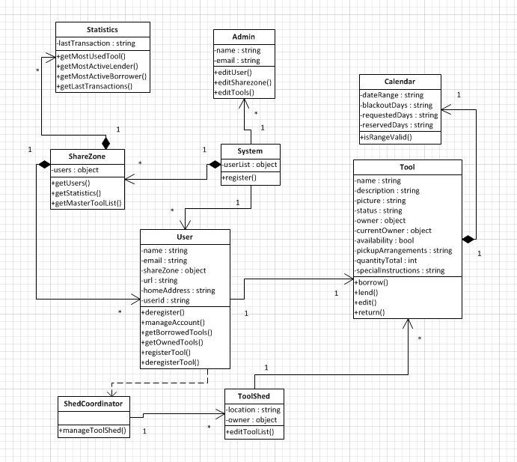

Sequence Diagram(s)
Place Order Acceptance Sequence
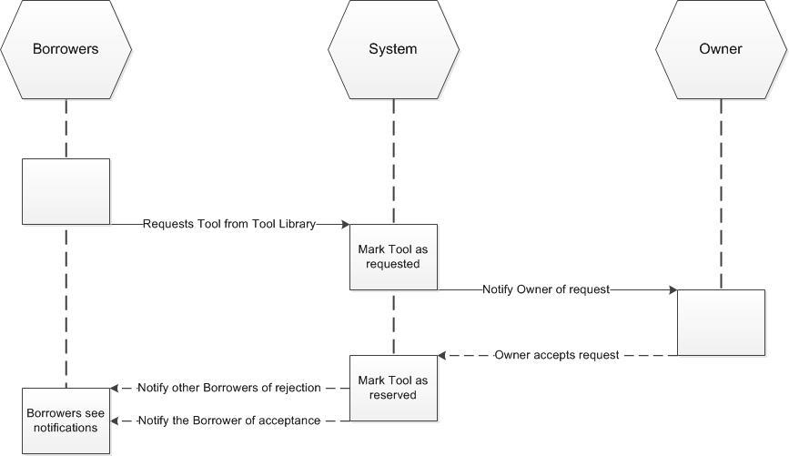

Place Order Reject Sequence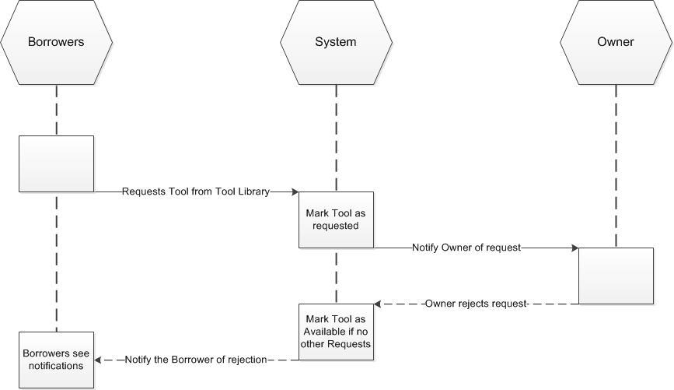

Design Rationale

Date | Action | Affected Areas | Benefits | Drawbacks
9/19/13 | Decided against ShareZones comprising of an inputted radius and instead used the zipcode classification | ShareZone | - Easier method to code  - Less arbitrary  - More community focused | If a User is on the outskirts of a zipcode and wants to use a neighbor’s Tools from another zipcode area, even if he is close he will be unable to do so.
9/21/13 | Completed Design Document | All | First release of Design Drawback | Unknown
10/1/2013 | Within Django’s django.contrib.auth, a a User’s “Group” will be their ShareZone | ShareZone | Relieves some work on us, the coders, to develop ShareZones | Unknown
10/06/13 | A seperate class to control what the index page for the website will be | UserProfile object | Cleaner code | Unknown
10/06/13 | Zipcode is now groupbased w/ permissions | ShareZone | Majority of the code is from built in libraries/database entries | Using the django group system is easy and more maintainable than anything 2nd year cs students could created
10/17/13 | Shed Creation will be done with Groups and Permissions | Sheds & Users | It is straightforward to add a tool to a group and then retrieve all members of a Tool Shed Group. The Shed Coordination would have a permission corresponding to said group | It gets messy when determining who has what within the Shed and who has which permissions

